**Storyboard**

The two cutscenes in the game consist of a series of still images accompanying a voice over. The rough images will be pictured here with the associated lines of narration below each.

**Intro Cutscene**

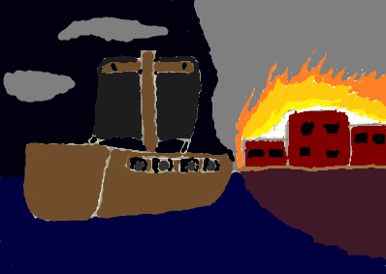

“In the year 732 DB, under the rule of the First Lords of the Admiralty, the nation of Valtameri was blighted by several seafaring bandits.”

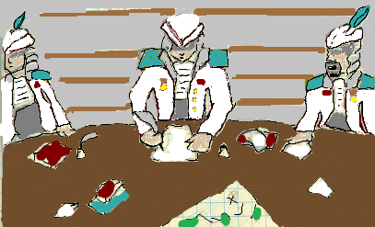

“Absorbed in their own interests, the First Lords of the Admiralty overlooked the suffering of the people at the hands of these bandits.”

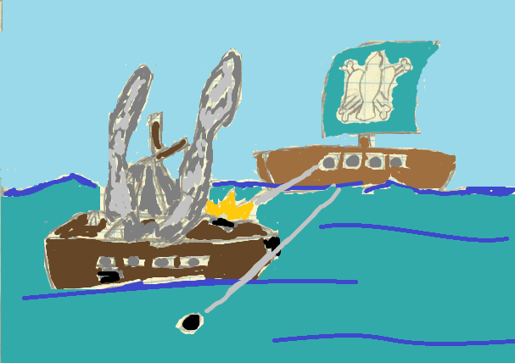

“To counter this threat, P.I.R.A.T.E.S. was created by civilians with the goal of maintaining peace and prosperity for the common folk.”

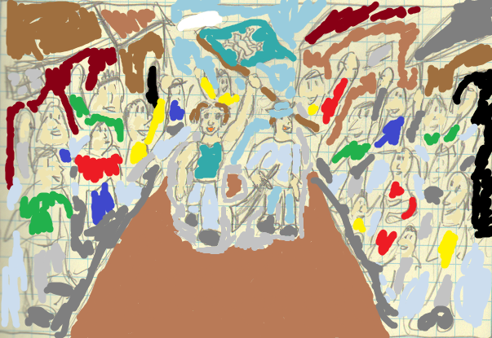

“For the next 70 years, growing both in strength and popularity, P.I.R.A.T.E.S. patrolled the waters enjoying official impunity for their peace-keeping actions.”

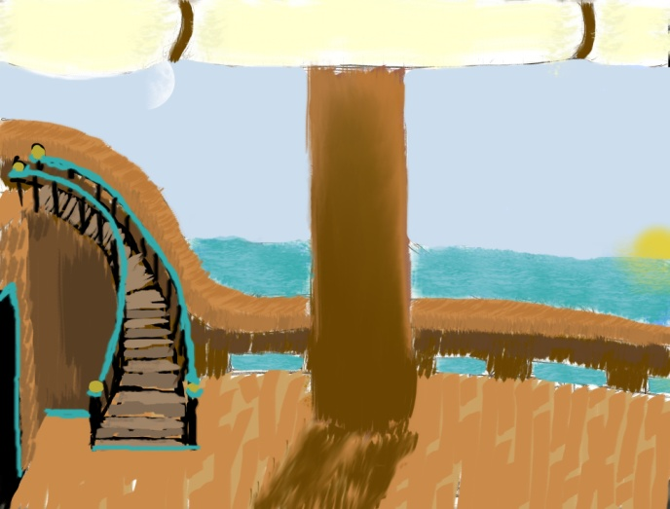

“Now, in the year 802 DB, a young first mate by the name of Moot Sile has just been promoted to captain.”

**Outro Cutscene**

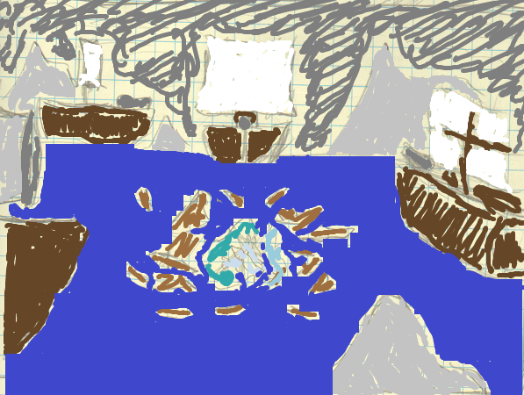

“Following the tragic deaths of Captain Moot Sile and his crew, the First Lords of the Admiralty declared themselves the saviors of the people.”

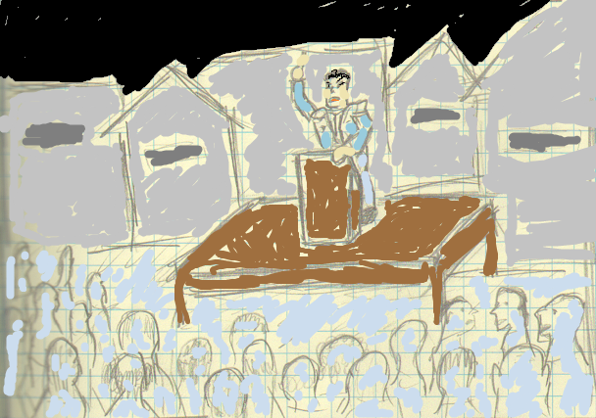

“However, P.I.R.A.T.E.S. representative Michael, after suffering a fit of conscience, declared to any that would listen the truth of Moot Sile’s final actions.”

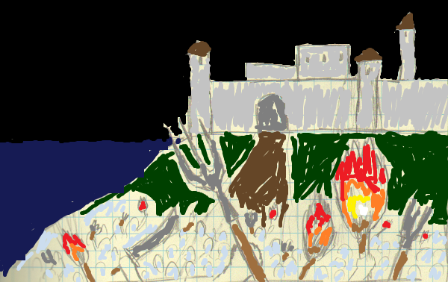

“Inspired by Michael’s story, and infuriated by the government’s lies, the citizens of Valtameri once again boarded ships and took up arms. This time, their enemy was the corrupted government.”

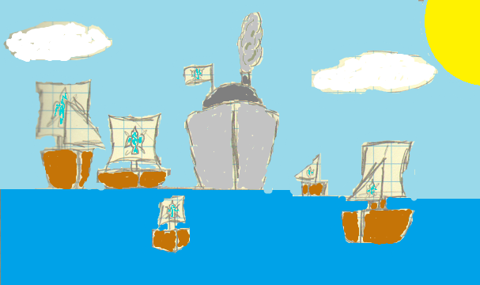

“Each ship that sailed against the First Lords bore the flag of P.I.R.A.T.E.S., not in recognition of the fallen organization, but in memory of the brave captain whose stubbornness forced even Fate to yield.”

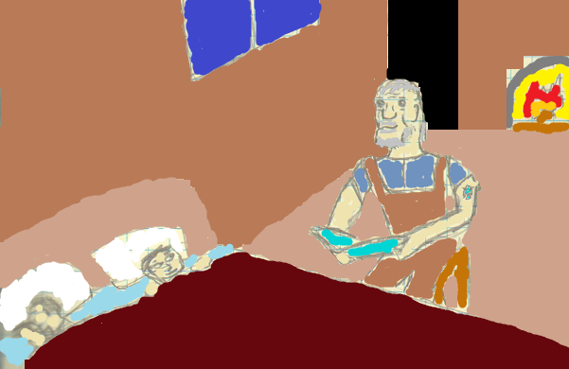

“This rebellion would give rise to heroes of its own. However, their stories are tales for another night.”